(Approx. 1068 words)

What’s New?
Reviews by George Harding, Treasurer, Tucson Computer Society, AZ
August 2016
www.aztcs.org
georgehardingsbd (at) earthlink.net

Etòn …

I received three products from Etòn for review. Eton, incorporated in 1986, is a Canadian company providing products in partnership with the Red Cross.

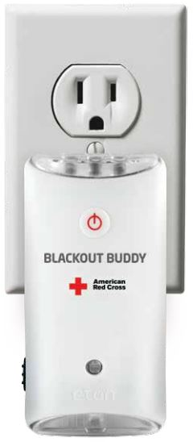
Blackout Buddy is a small unit about the size of a cell phone and provides you with a night light, blackout alert and an emergency flashlight. It has prongs for a wall socket, which turns it into a nightlight. If power goes out, the flashlight automatically turns on and gives you a bright beam from its three LED bulbs. If you remove it from the wall socket and fold the prongs in, it is now a flashlight. This is a handy product for your home and is very reasonable priced at $15.

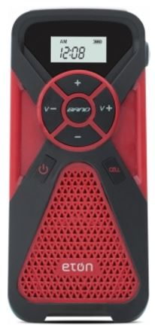
FR1 is a combination radio and cell phone charger. It has an internal battery that can be charged with the included cable or by using the embedded crank. Four minutes of cranking gets you 10-15 minutes of radio time. There are three radio bands, AM, FM and Weather. Controls on the face of the FR1 allow you to change band, change radio station and change volume. There is a collapsible antenna on the side of the FR1. Another button on the face activates the cell phone charging port. When in Weather band mode, you can set a monitor to turn the FR1 on whenever the station issues an alert for hazardous weather. You can also set an alarm to sound at a particular time. This product is versatile and would be an essential item to have on backpacking and camping trips, or even on a driving trip. It’s modestly priced at $45.

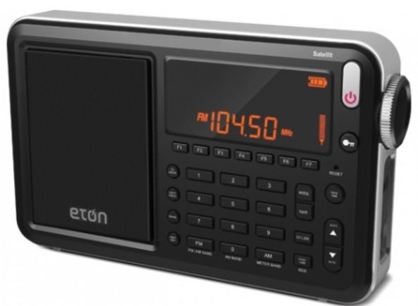
Satellit is a multi-purpose radio receiver with many features. It receives AM, FM, LW, shortwave and aircraft bands. It includes a clock and alarms can be set and there is a sleep timer, as well. There is capacity for up to 700 memory channels. It is powered by either a wall plug or by 4 AA batteries. If the batteries are NiMh rechargeable, running the radio on wall power will charge the batteries. A collapsible antenna is stored on the back of the box. The box includes a very nice carrying bag. Both audio in and out are supported. The unit includes a very thorough User Manual with sections in English, French and Spanish. With the many features and options available with this product, the complete manual is a necessity. Priced at$230 through the company, although Amazon advertises the product at $159 at this writing.

Etón Corp. www.etoncorp.com

I-Sleep …

If you have trouble getting to sleep, this product may be for you. It is scientifically designed to use your brain’s impulses to enhance the likelihood of sleep.

The kit comes with several parts. The first is a controller which outputs a signal to your circulatory system and ultimately your brain. It includes a control for you to increase or decrease intensity of the signal. It has an internal battery and a charging cable is included to enable this. The controller has a monitor screen which shows information.

The kit also includes a set of what might be earbuds if the ends were to go into your ears. In this case, though, the ends clip onto your ear lobes. There are cloth pads that fit onto the clips, that must be moistened for connectivity. The manual suggests eye drops as a moistening agent.

When you are ready to go to sleep, you attach an ear clip and turn on the controller. Twenty minutes’ time is shown on the monitor and countdown starts. After twenty minutes, the controller automatically turns off.

While on, you may adjust the intensity of the signal put out by the controller. You increase or decrease as needed.

The Company description of operation is: “The product uses advanced bioelectricity to balance brainwave technology to increase the activity of Alpha wave, reduce the activity of Delta waves, in order to improve sleep quality. About 20 minutes after using it, you will fall into a deep sleep.”

This innovative product is not yet available to the public. I received it for review as an Xberts Pioneer.

I-Sleep by Xberts No web access at this time Price: $169

Nite-Ize …

This is one of the most innovative companies I’ve come across. They develop useful tools for you and me that are easy to use and reasonably priced. Here are a few that the Company provided me for review.

- Steelie Pedestal for Tablets. This device is pretty simple, but fills the need for a support when you use a tablet on a flat surface There is an adhesive-backed magnetic disc, the Steelie stalk and mount for a desk or other flat surface. You attach the magnetic disc to the back of your iPad or other tablet and place the mount on a flat surface. The Steelie stalk head fits into the magnetic disc and the end goes on the mount. The tablet can be rotated and tilted as needed. Price $50
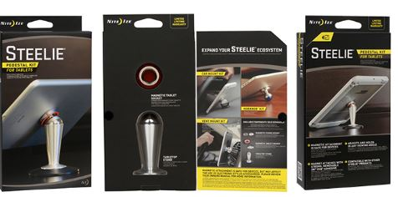
- Steelie Vent Mount Kit. This is similar to the Pedestal product, but has a mount that clips easily to most vehicle vents. It keeps any cell phone securely attached, yet is easy to manipulate. Don’t drive and manipulate! Price $40
- Financial Tool. Holds currency, driver’s license and credit cards securely and serves as a multi-tool as well. Tools are: screwdriver, tape cutter, ruler, windshield scraper, wrench and bottle opener. All this in a stainless-steel frame! Price $10
- 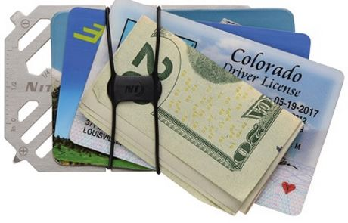 | - 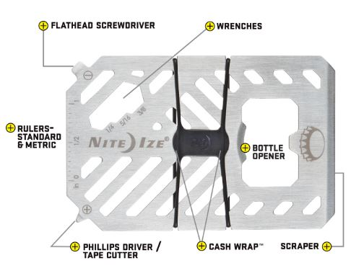

- Mini flashlight. Has functions for flashlight, lantern and safety light. The flashlight has two levels of brightness, high and low. The lantern also has two modes, high and low. The safety light has three modes, glow, flash and SOS. All this in a machined aluminum body and takes only one AA battery. Price $12
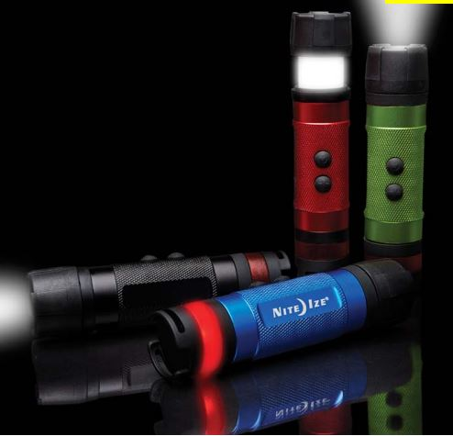
- BetterBand. Stretch bands that can hold things together, link cords, bags of chips, etc, or use as a tie-down to something else. Price $4 There are many other versions of these bands in different lengths. Handy for keeping thing together.
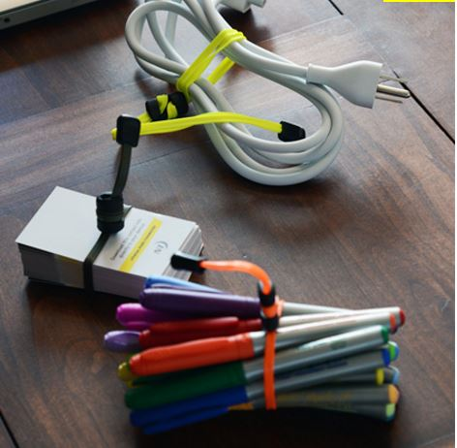
- PowerKey. A small container for a cable with an iPhone 5/6 attachment and USB plug. Price $18
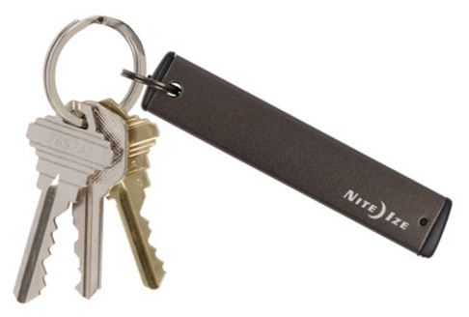
- GearTie. A flexible rubberized wire, useful for keeping items together. Comes in various lengths. Price $4.50 for 6-inch pair.
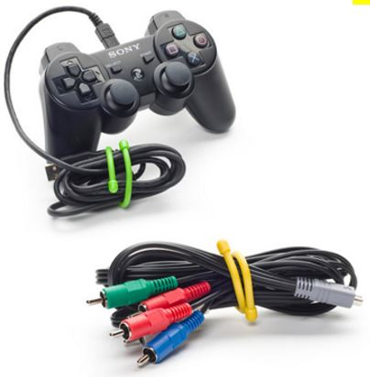
There are many more useful products in the Nite-ize catalog. See http://www.niteize.com

